**Energy Utility Platform**

**Student: Bodea Razvan-Marius**

**Group: 30441**

**Contents**

**1.** **Requirements analysis** 3

**1.1** **Assignment specification** 3

**1.2** **Functional requirements** 3

**1.3** **Non-functional requirements** 3

**2.** **Use-case model** 3

**3.** **System architectural design** 5

**3.1** **Architectural pattern description and diagrams** 5

**Component diagram** 6

**Deployment diagram** 6

**4.** **Class design** 7

**4.1**  **UML class diagram** 7

**4.2** **Data model** 8

**5.** **Bibliography** 8

1. **Requirements analysis**
   1. **Assignment specification**

Develop a chat system to offer support for the clients of the energy platform if they have questions related with their energy consumption. The chat system should allow communication between the clients and the administrator of the system.

* 1. **Functional requirements**

➢ The client application displays a chat box where clients can type messages.

➢ The message is sent asynchronously to the administrator, that receives the message together with the client identifier, being able to start a chat with the client.

➢ Messages can be sent back and forth between the client and the administrator during chat session.

➢ The administrator can chat with multiple clients at once.

➢ A notification is displayed for the user when the other user reads the message.

➢ A notification is displayed for the user (e.g., typing) while the user from the other end of communication types its message.

* 1. **Non-functional requirements**
* Availability: the application is available 99% of the time
* Performance: the application’s response time is below 200 ms for 95% of the requests
* Security: the application’s minimal security is assured by authentication and authorization, password hashing and encryption of sensitive information + (jwt tokens)
* Usability: the application has a user-friendly interface, appropriate for people of all ages

1. **Use-case model**

**2.1 User view device measurements**

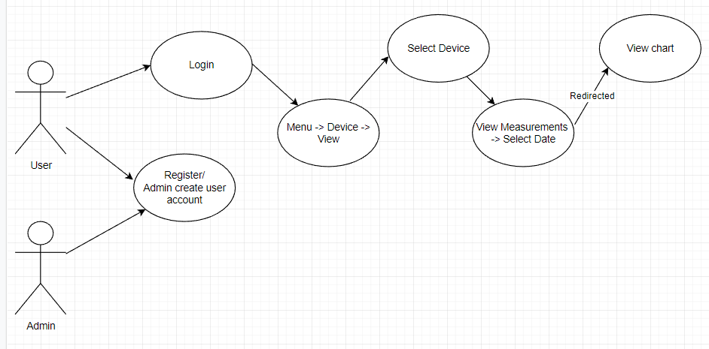

**2.2 Admin add measurement**

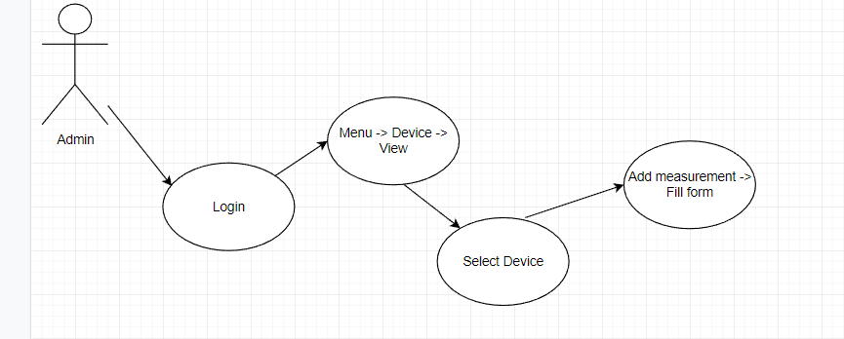

1. **System architectural design**
   1. **Architectural pattern description and diagrams**

Layered architectures are said to be the most common and widely used architectural framework in software development. It is also known as an n-tier architecture and describes an architectural pattern composed of several separate horizontal layers that function together as a single unit of software.

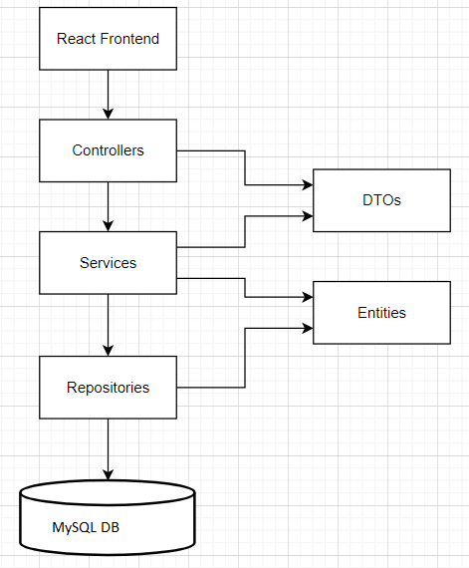

### **Component diagram**

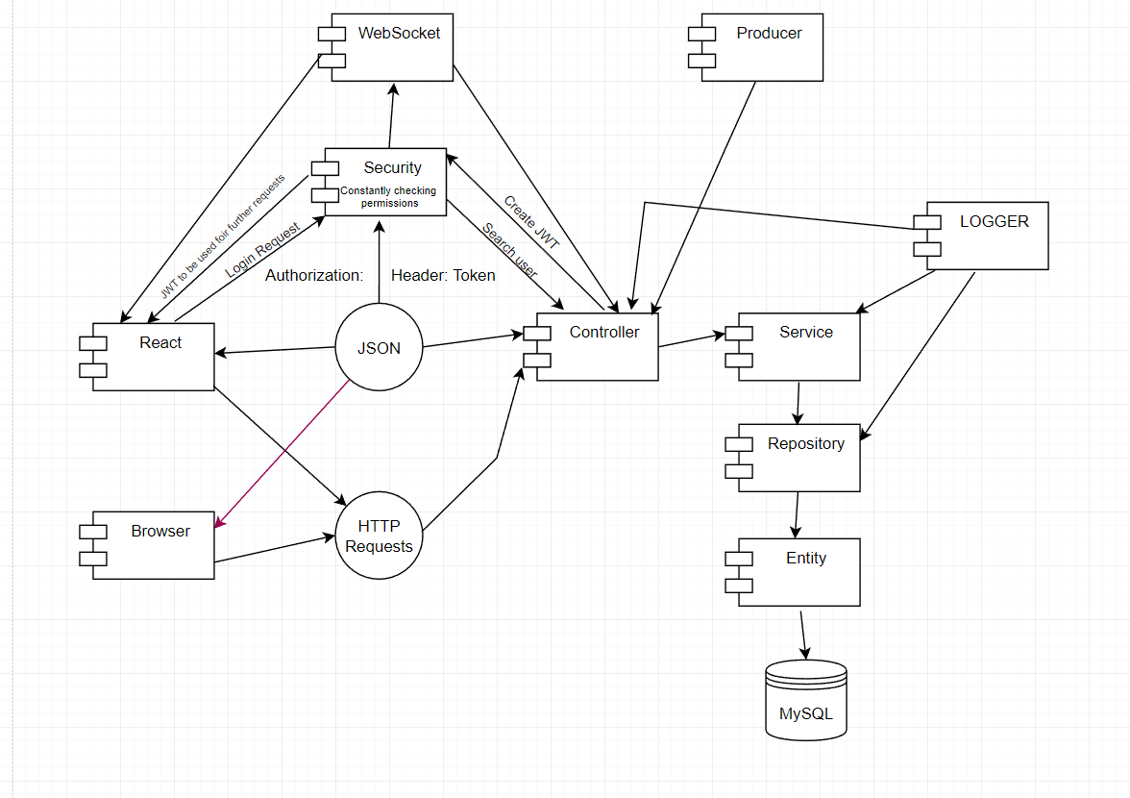

### **Deployment diagram**

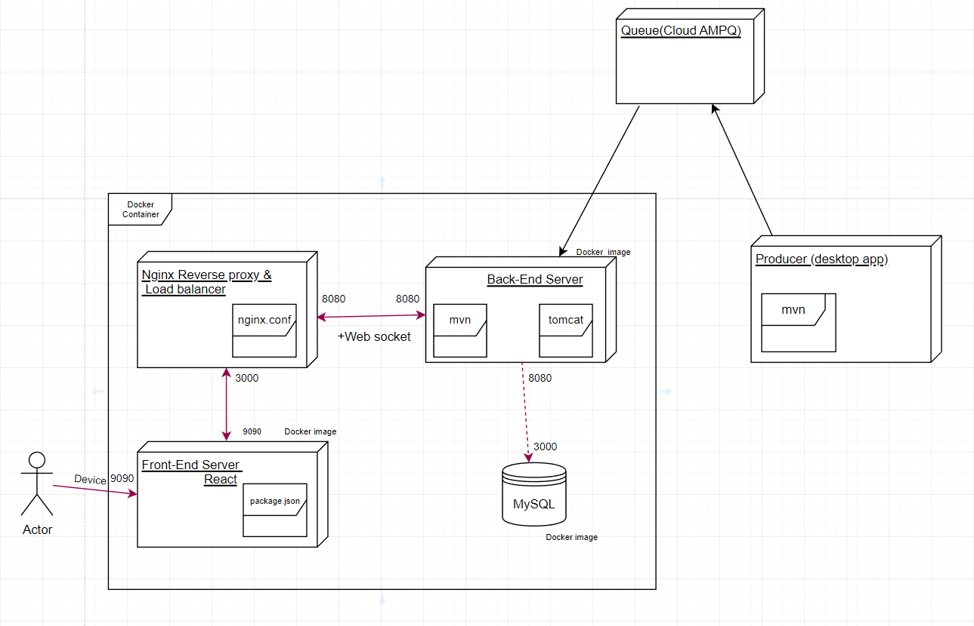

1. **Class design**

**4.1 UML class diagram**

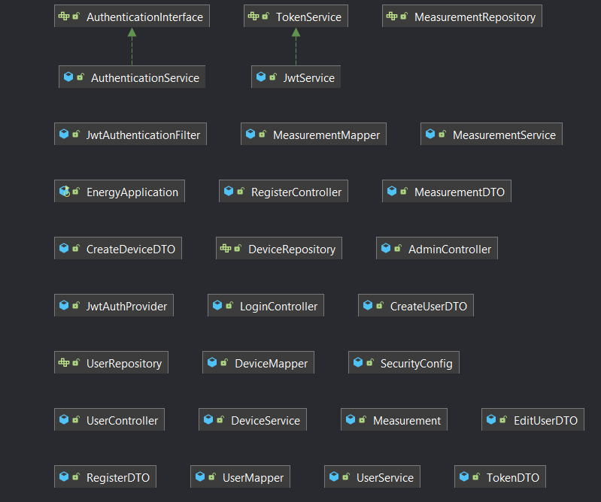

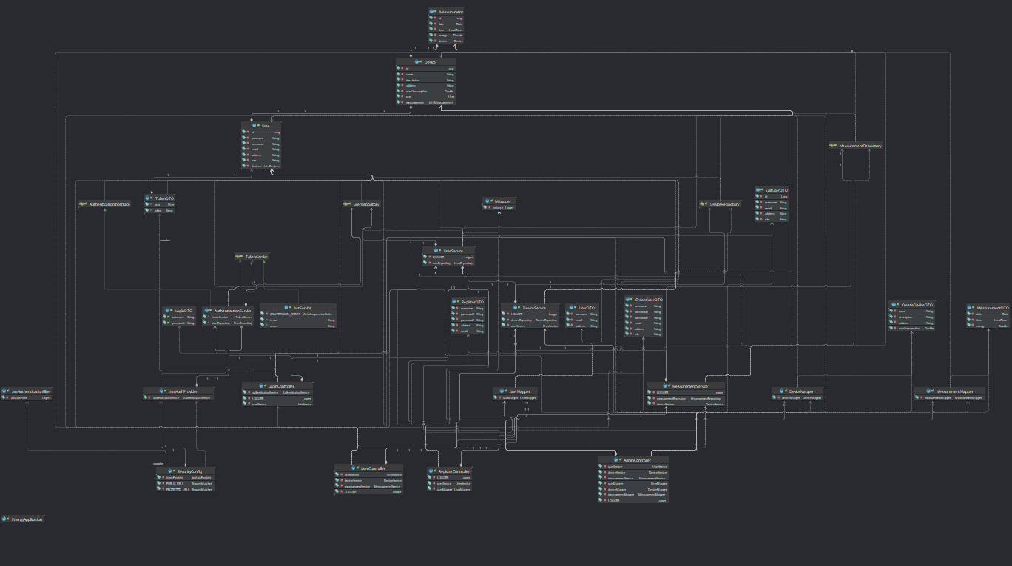

## **4.2 Data model**

